Capstone Project Weekly Progress Report
Semester | Fall-2024 Semester 3rd
Course Code | AML-3406
Section | Section 1
Project Title | Car Damage Detection
Group Name | Group B
Student names/Student IDs | Sakshi (C0908000) – TL  Bansil Patel (C0912873)  Harsh Mohile (C0912872)  Meet Patel (C0910378)  Rachit Bhatt (C0902810)
Reporting Week | Week 7
Faculty Supervisor | William Pourmajidi

Grade the level of collaboration from different aspects between team members:
(use: good, medium, below expectation)
Sakshi | Bansil Patel | Harsh Mohile | Meet Patel | Rachit Bhatt
Good | Good | Good | Good | Good

Tasks outlined in the previous Weekly Progress Report for this reporting week at the individual level and group level
  - Individual tasks (each team member)
Sakshi: Research on docker.
Bansil Patel & Meet Patel: Analyze model outcomes and implement metrics.
Harsh Mohile & Rachit Bhatt: Demonstrate GitHub Actions.
2.2 Your team’s tasks
- Analyze model performance and implement metrics.
- Understand working of GitHub Actions.

Progress made in Reporting Week at an individual level and group level
  - Individual progress
Sakshi: Workflow of docker and its importance.
Bansil Patel & Meet Patel: Analyzed model outcomes and initiated working on metrics.
Harsh Mohile & Rachit Bhatt: Studied GitHub Actions.
  - Your team’s progress
- Worked on understanding GitHub Actions by creating a demo project; GitHub - Actions.

The areas/tasks you could not make progress and/or complete as scheduled or the difficulties encountered in this reporting week at individual level and group level.
  - Individual project blockers
Sakshi: N/A
Bansil Patel: N/A
Meet Patel: N/A
Harsh Mohile & Rachit Bhatt: Improving GitHub deployment for each yml created and overhead of failures.
  - Your team’s project blockers
- Installation of docker blocked the progress speed.

Tasks to be completed in the next week at individual level and group level
  - Individual tasks
Sakshi: Install docker and work on creating containers.
Bansil Patel & Meet Patel: Apply alternative models or initiate hyperparameter tuning.
Harsh Mohile & Rachit Bhatt: Create a demo project on GitHub Actions.
  - Your team’s tasks
- Apply new models and hyperparameter tuning.
- Demonstrated a project using GitHub Actions.

Include the tasks from your sprint planning (Github/Zenhub) for the present period.
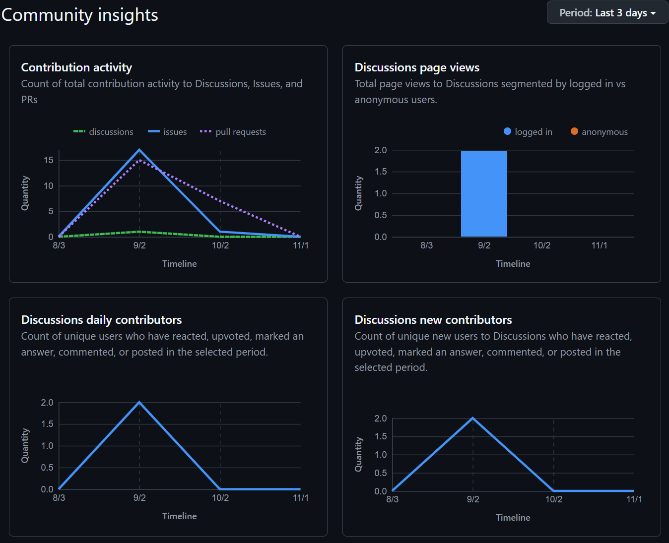
Figure 1: Weekly Activities
- In this week, there were 17 contributions made with 15 PRs, contributing in development.

Include charts/graphs (e.g., burn down charts) from your project management tool (Github/Zenhub) that shows your progress for the period of this report.
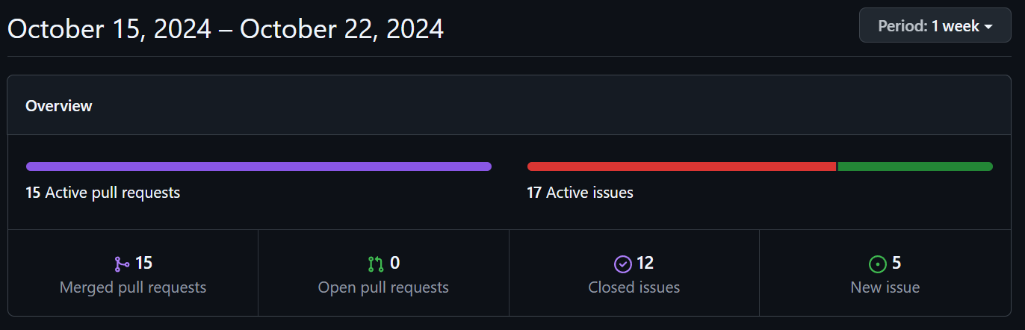
Figure 2: Contributors in the Week
- This week, we had quite a lot of PRs compared to previous week, demonstrating team hard work and dedication.

Include a note and address to your project GitHub with list of codes uploaded/updated on GitHub in this reporting week.
GitHub: https://www.github.com/rachit-bhatt/Capstone-Project

